

Clarity CC 75- Vitreous China Rimless One-Piece Elongated Toilet with Skirted Trapway Floor Outlet, 1.28 gpf (4.8 lpf) with Seat

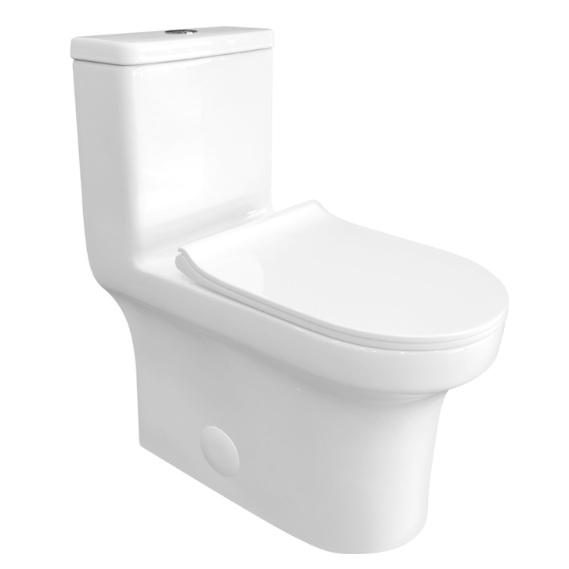
DIMENSIONS
COLOURS AND FINISHES
Gloss White
Length | 27’’
Width | 14-3/4’’
Height | 30-1/8’’
Seat Height | 16-7/16’’

CERTIFICATIONS & APPROVALS

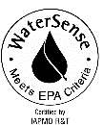

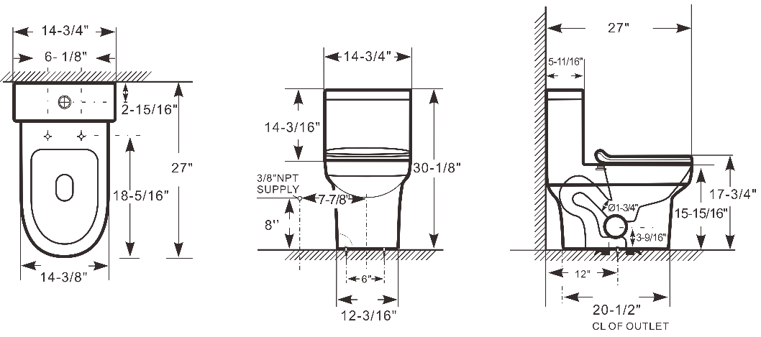

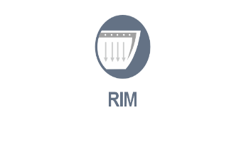

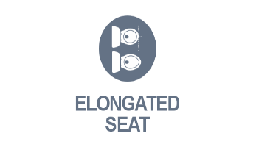
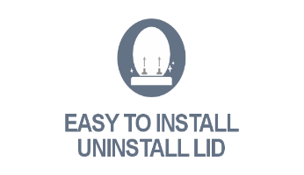
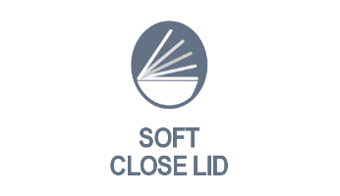



FEATURES
Flushing system | Rim Holes Flush, Dual flush
Nominal water consumption | 1.28 GPF Full flush/ 1.08 GPF Half flush
Material | Vitreous china
Rough-in | S-Trap 12’’
Flush button type | Buttons
Bowl Shape | Elongated
Seat height | 16-7/16’’
Lid Shape | Elongated, Urea-Formaldehyde (UF) Thermoset Plastic or PP, soft close, quick release
Trapway size | 1-3/4’’

Images are for illustrative purposes only.

COMPATIBLE WITH

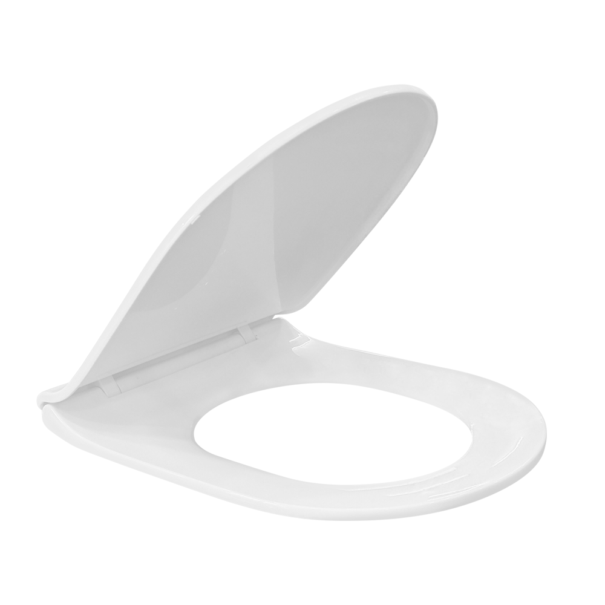
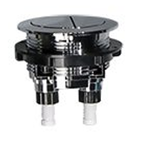
Dual Flush Buttons for
Clarity Toilet

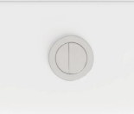

Urea-Formaldehyde (UF) Thermoset Plastic or PP, Soft Close Quick-Release, Easy-Clean lid for Clarity CC 75 Toilets

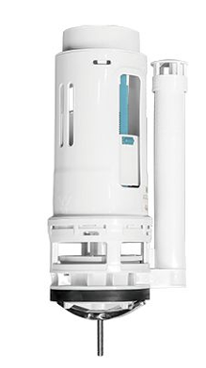
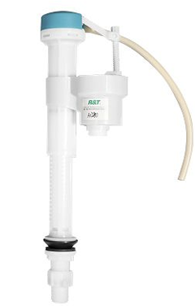
R&T FLUSH VALVE, DUAL FLUSH for
Clarity Toilet
R&T INFILL VALVE for
Clarity Toilet

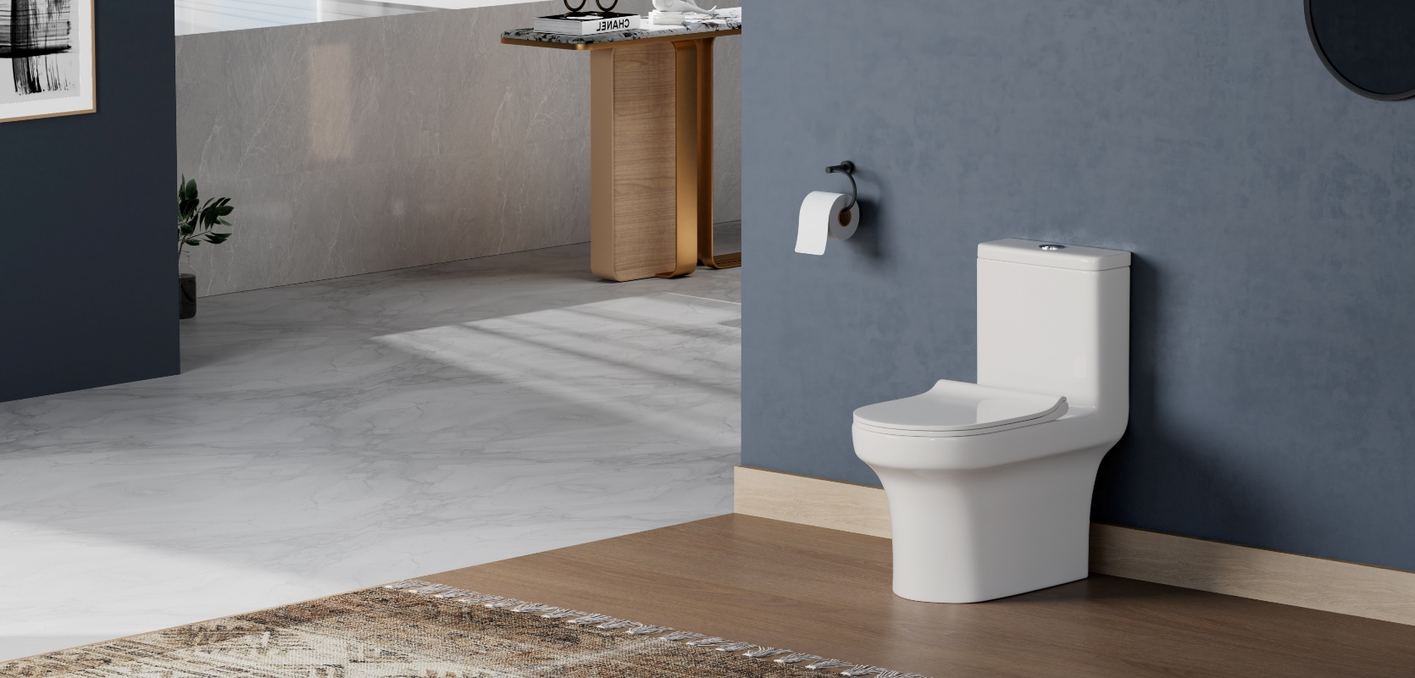

TECHNICAL REQUIREMENTS
Toilet type | One-piece Toilet
Installation Type | Floor-mounted
Water surface size | 8-1/8“ x 5/1/2”
Min static pressure | 20 psi
Max static pressure | 80 psi
Min flowing pressure | 25 psi
Min flow rate | 0.43 gpm
Water Supply Location | ~8’’ from floor to inlet, and 6’’ – 8’’ offset from centerline

STANDARDS
ASME A112.19.2/CSA B45.1
U.S. EPA WaterSense® Specification for HETs (High-Efficiency Toilets)
U.S. Department of Energy (DOE) Energy Policy Act 1992
ADA / ICC ANSI A117.1 (when installed per code)
Certified by IAPMO R&T
California Energy Commission (CEC)
ICC/ANSI A117.1
CSA B651

KEY ADVANTAGES
- High-Efficiency 1.28 GPF Flushing System
Consumes only 1.28 gallons per flush, fully compliant with the EPA WaterSense® and cUPC certification standards—saving water while delivering strong flushing performance.
- Skirted Trapway for Easy Cleaning
The fully skirted design conceals the trapway, giving the toilet a sleek, modern look and making the exterior easier to clean.
- Elongated Bowl for Superior Comfort
The elongated seat offers more space and better ergonomics than round-front bowls, enhancing user comfort during use.
- Standard 12" Rough-In Compatibility
Designed with a 12" rough-in, suitable for most residential and commercial bathroom installations in the U.S. market.
- Soft-Close Thermoplastic Seat Included
Comes with a quiet-close thermoplastic seat to prevent slamming, reduce noise, and increase durability during everyday use.
- High-Quality Glazed Vitreous China
Made of premium glazed ceramic, featuring a smooth, stain-resistant surface that ensures long-lasting durability and a polished appearance.

INCLUDED COMPONENTS
Standard Package Includes:
- One-piece vitreous china toilet
- Thermoplastic or PP soft-close toilet seat
- Seat mounting hardware kit
- Flush system set (fill valve + 3" flush valve)
- Chrome-plated flush button
- Floor mounting bolt kit
- Wax ring seal
- Decorative bolt caps (2 pcs)
- Installation manual (English)

Water supply line and angle stop valve are not included and must be purchased separately.

